Student’s name | …………………………………………………….…… | Grade | 1
Subject | Computer | Week No. | 3
Lesson Title | Files and Folders | Unit
Worksheet No. ( 3 ) (Answer)

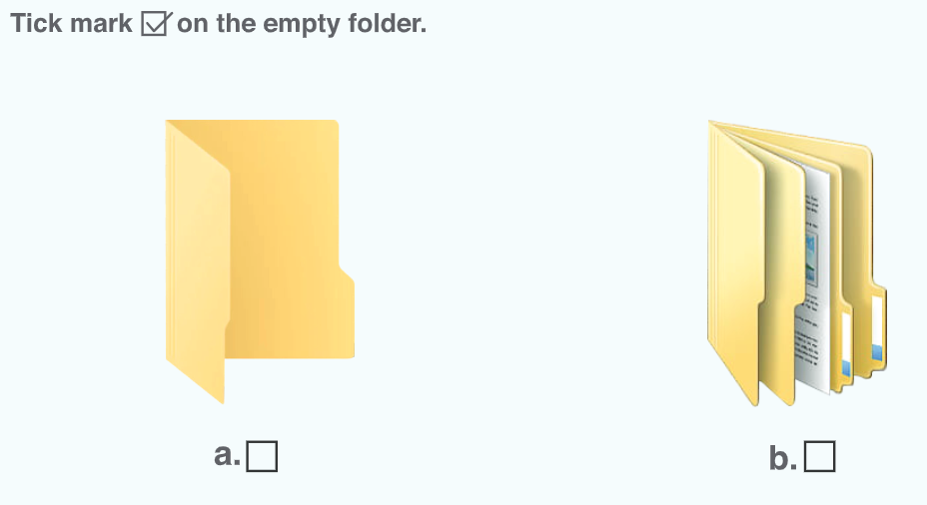
✔
Good Luck

